**July 14, 2022: Construction Update No. 9**

**Woodbine Area Reconstruction Project**

**Project Nos. 2022-01, 02, 03, & 04**

The Contractor has completed misc. removals, utility work and removal of pavement and installation of new pavement in stage 1. They will be finishing up utility work in stage 2 this week.

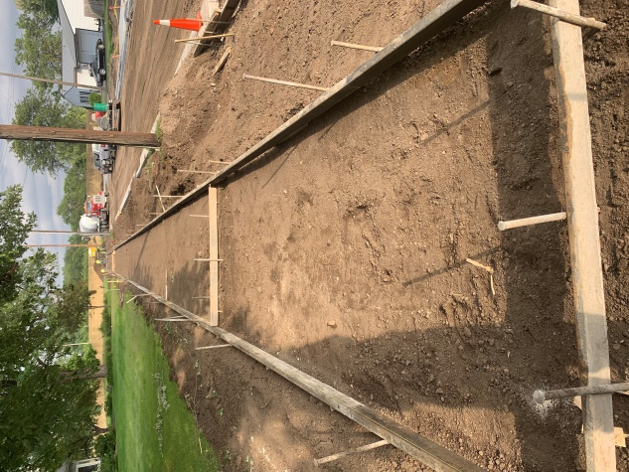

This week’s (7/11-7/15) work will include the following activities:

* New sidewalk grading on stage 1
* Continuation of water shutoff replacement in stage 2.
* Reconnection back to permanent water in stage 2.

Next week’s (7/18-7/22) work will include the following activities:

* Restoration work in stage 1.
* New sidewalk grading on stage 1
* Concrete work in stage 1 and stage 2.
* Miscellaneous curb and sidewalk removals in stage 2.

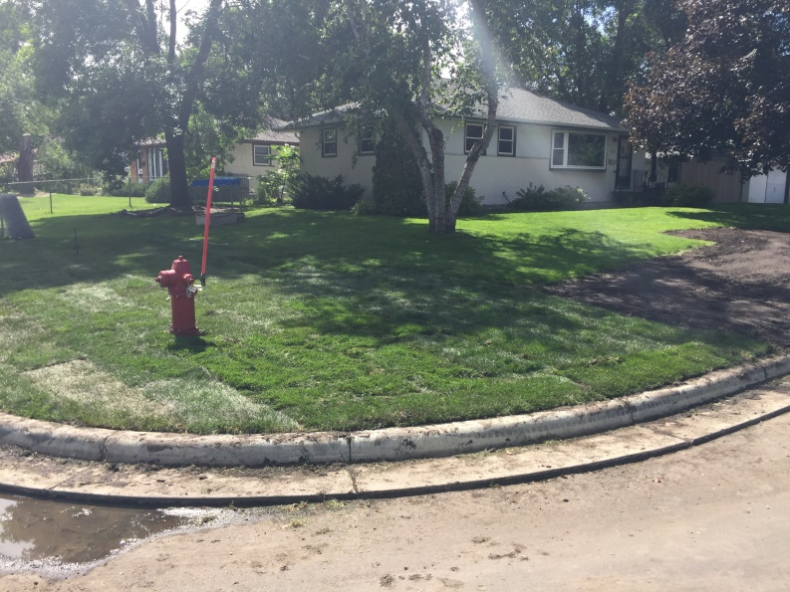Keep children away from the construction. Construction activity and machinery can often attract the attention of curious children. Your assistance in directing your children away from construction areas is appreciated. Construction vehicles can move quickly and suddenly. Please stay clear of machinery and construction stockpiles and trenches.

For any questions or concerns you may contact the following City of Brooklyn Center Engineering Staff:

Trevor Williams, Project Manager, 763-569-3324, [twilliams@ci.brooklyn-center.mn.us](mailto:twilliams@ci.brooklyn-center.mn.us)

Nathan Braman, Project Inspector, 763-569-3323, [nbraman@ci.brooklyn-center.mn.us](mailto:nbraman@ci.brooklyn-center.mn.us)

Erik Knutson, Project Inspector, 763-569-3331, [eknutson@ci.brooklyn-center.mn.us](mailto:eknutson@ci.brooklyn-center.mn.us)

If you have an AFTER hours emergency, such as a sewer back up, street flooding, etc., please dial 911 and the dispatcher will contact the Brooklyn Center Public Works Duty Person to assist you.

