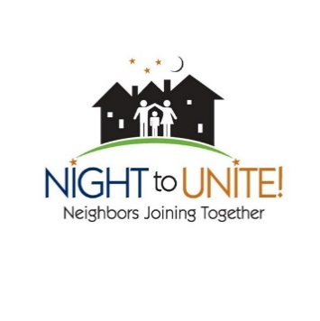

Save the date!

Date: _______________________



Grab your calendar so you don’t forget our neighborhood celebration! Let’s turn on the front porch lights, get to know one another, catch up after a long winter, play some games, enjoy food and build a sense of community. More details coming!



BROOKLYN CENTER

NIGHT TO UNITE

Save the date!

Date: _______________________

Grab your calendar so you don’t forget our neighborhood celebration! Let’s turn on the front porch lights, get to know one another, catch up after a long winter, play some games, enjoy food and build a sense of community. More details coming!

You’re invited

BROOKLYN CENTER

NIGHT TO UNITE



Save the date!

Date: _______________________



Grab your calendar so you don’t forget our neighborhood celebration! Let’s turn on the front porch lights, get to know one another, catch up after a long winter, play some games, enjoy food and build a sense of community. More details coming!



Save the date!

Date: _______________________



Grab your calendar so you don’t forget our neighborhood celebration! Let’s turn on the front porch lights, get to know one another, catch up after a long winter, play some games, enjoy food and build a sense of community. More details coming!

BROOKLYN CENTER

NIGHT TO UNITE

BROOKLYN CENTER

NIGHT TO UNITE